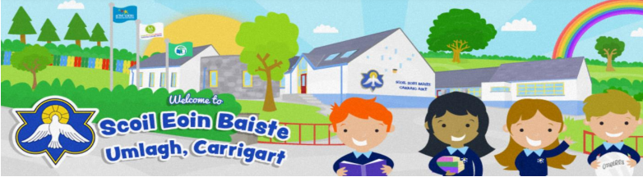

Board of Management
Agreed Report Term 1
School Ethos | - The board would like to welcome all pupils and staff back to school and extend a particular welcome to our new pupils who have joined junior infants and classes up along the school. We are looking forward to a good, successful year ahead.  - Our first celebration of Mass took place on Friday 29th September. Many thanks to all who came to celebrate the start of a new school year with us.
School Policy | - Child Safeguarding and Risk Assessment-The Child Safeguarding Statement and Risk Assessment Policy was formally ratified for 2023/2024.The Annual Review Checklist was completed by the Board. The Child Protection Procedures for Primary and Post -Primary schools (revised 2023) were adopted.  - Anti-Bullying Policy-The Anti-Bullying Annual Review Checklist has been completed by the Board of Management.  - Organisational Planning Diary 2023/2024  - Curricular Planning Diary 2023/2024  - Deputy Principal Duties completed 2022/2023  - Assistant Principal II Duties completed 2022/2023
Staffing | - Principal- Breda Mc Geever  - Assistant Principal 1- Seamus Connor  - Assistant Principal 11- Tina Mc Laughlin  - The school currently have 6 mainstream class teachers and 1 autism class teacher.  - 2 special education teachers  - 5 special needs assistants  - EAL teachers  - 1 full time secretary  - The board extends a warm welcome to Miss Mallon who has joined us and is working as a special education teacher.
School Events | - Maths week will take place from October 13th to October 21st- There will be school wide activities taking place on Friday October 20th.  - Parent teacher meetings- Thursday 19th October  - Rang a 4 are taking part in Steps Young Engineering Competition in December.  - Rang a 5 are taking part in the BT Young Scientist Competition in January.  - Rang a 5 agus a 6 are entering the Concern Debating competition.  - Proposed date for Christmas Show- Thursday 21st December.  - All children are welcome to dress up in Halloween costumes on Friday 27th October.
Curriculum Development | - Two members of staff will attend an information seminar in the new Maths Curriculum and Well-being in October and report all relevant information to school staff at the following Croke Park meeting.  - The school are engaging in School Self Evaluation Process.  - Weekly awards will be presented by Mrs Mc Geever:  A general Dalta Na Seachtaine Award  Scribhneoir na Seachtaine- To promote clear, tidy cursive handwriting.  Gaelgeoir na Seachtaine- To promote the use of Irish as the language of communication around Scoil Eoin Baiste.  - We are very fortunate to have the Úna Collier from Mevagh Resource Centre covering the ‘Healthy Me’ SPHE programme for our 5th class pupils.  - PE- Physical Education takes place on a  Wednesday- GAA coaching with Manus  Thursday- Athletics and Games with Syria  Due to the poor weather we have had to cancel PE for a number of weeks. The school are not permitted to use the Parish Hall next door. Board members to meet with Parish Hall Committee members to discuss.
Parental Involvement | - The school’s Parents Association have raised a total of €5300 since they formed in February 2023. This is a huge achievement and the board wish to thank them for their continuous hard work. The Parents Association have organised another Quiz Night scheduled for Friday 13th of October and a Craft Fair on December 3rd.  - A message to be sent to all parents to remind them to use the crossing outside the school when crossing the road with their children. The wearing of Hi- Vis vests to be promoted during the winter months also.
New Board of Management | - A new Board of Management will be elected for the 2023- 2027 period. The new board will come into effect from December 1st 2023. The Board have agreed to proceed with Option 2 of Appendix B Governance Manual for Primary Schools 2023 – Procedure for the nomination/election of a parent(s) for appointment by the patron as a parent nominee(s) to the board.

