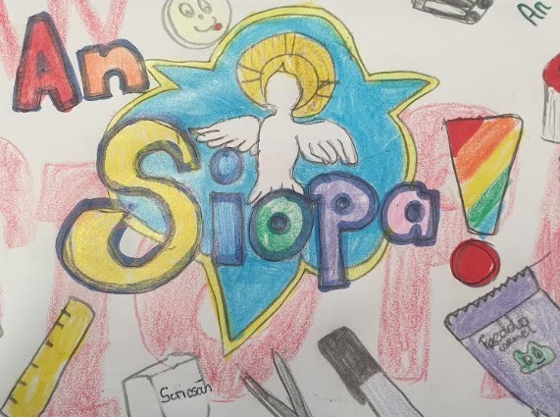
Beidh An Siopa oscailt arís Dé hAoine seo chugainn.

Stationery and small treats will be available for the children to buy. The small treats cost 50c and the stationery ranges in price from 50c to €1.50.

Ádh mór dona páisti ó rang a sé a mbeidh ag obair sa siopa.

